Jordan University of Science and Technology
Faculty of Computer and Information Technology

CS362 – Artificial Intelligence

Phase One Report

Student Name | Leen Mahmoud
Student ID | 165930
Semester | Second Semester 2025/2026
Submission Date | May 2026

Selected Datasets
For this project, I decided to work with two different datasets from Kaggle to cover both classification and regression tasks.
- Dataset 1 (Fetal Health): This is for Classification. It has 2,126 records and 22 features. The goal is to predict the fetal_health category (1, 2, or 3).
"Note: The labels were shifted from (1, 2, 3) to (0, 1, 2) during preprocessing to ensure compatibility with the classification algorithms."
- Dataset 2 (Body Fat): This is for Regression. It's a smaller dataset with 252 rows and 15 features, where we try to predict the BodyFat percentage as a continuous number.

Why I chose these tasks?
- 2.1 Fetal Health (Classification)
I picked this one for classification because the outcome we’re looking for isn't a range of numbers, but rather three specific categories: Normal, Suspect, and Pathological. The data comes from CTG scans (like heart rate and contractions), and the goal is to sort each case into one of these three buckets. Since we are dealing with distinct labels, it’s a perfect fit for a classification model.
- 2.2 Body Fat Prediction (Regression)
On the other hand, I chose the Body Fat dataset for regression. Here, we aren't trying to put people into "groups," but we want to predict an exact percentage of body fat (like 15.5% or 22.1%). This target is a continuous numerical value based on body measurements like weight, height, and abdomen
circumference. Because we’re predicting an actual number, it has to be a regression task.

EDA – Exploratory Data Analysis

Fetal Health

Summary Statistics
I started by running describe() to get an overview. All 2,126 rows are complete, so there are no missing values to worry about. However, I noticed a huge range difference between features; while baseline value is around 130, accelerations is a tiny decimal (0.019 max). This confirmed that Feature Scaling is a must-do step before training.

Class Distribution
I used a countplot to check how many samples we have for each health category. Class 1 (Normal) dominates the dataset at around 77%, making it clearly imbalanced. I’ll need to handle this in Phase Two, perhaps by using better metrics like the F1-score instead of just accuracy.
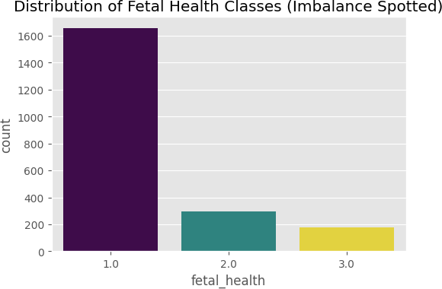
Figure 1: Distribution of fetal_health classes showing clear class imbalance

Feature Distributions
I plotted histograms for the main clinical features to see their "shape." Most of them, like fetal_movement and decelerations, are right-skewed, meaning most cases have low values while only a few abnormal cases show higher numbers. This is typical for medical datasets.

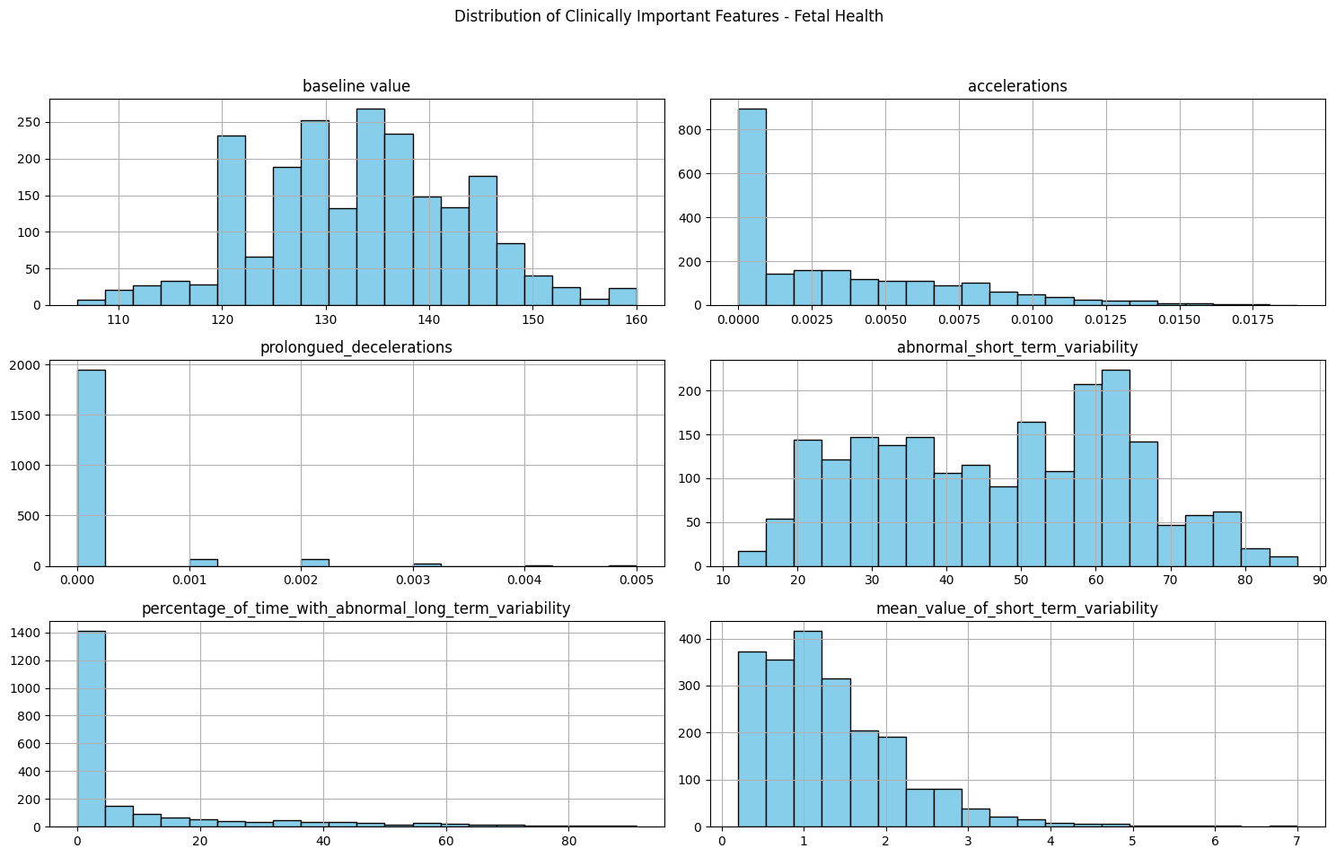
Figure 2:Distribution of clinically important features.

Correlation Heatmap
The heatmap was key to seeing which features actually impact the health class. Features like prolongued_decelerations and abnormal_short_term_variability showed the strongest correlations. I also used this map to identify redundant features (like histogram_mean and median) which I later dropped to avoid multicollinearity.

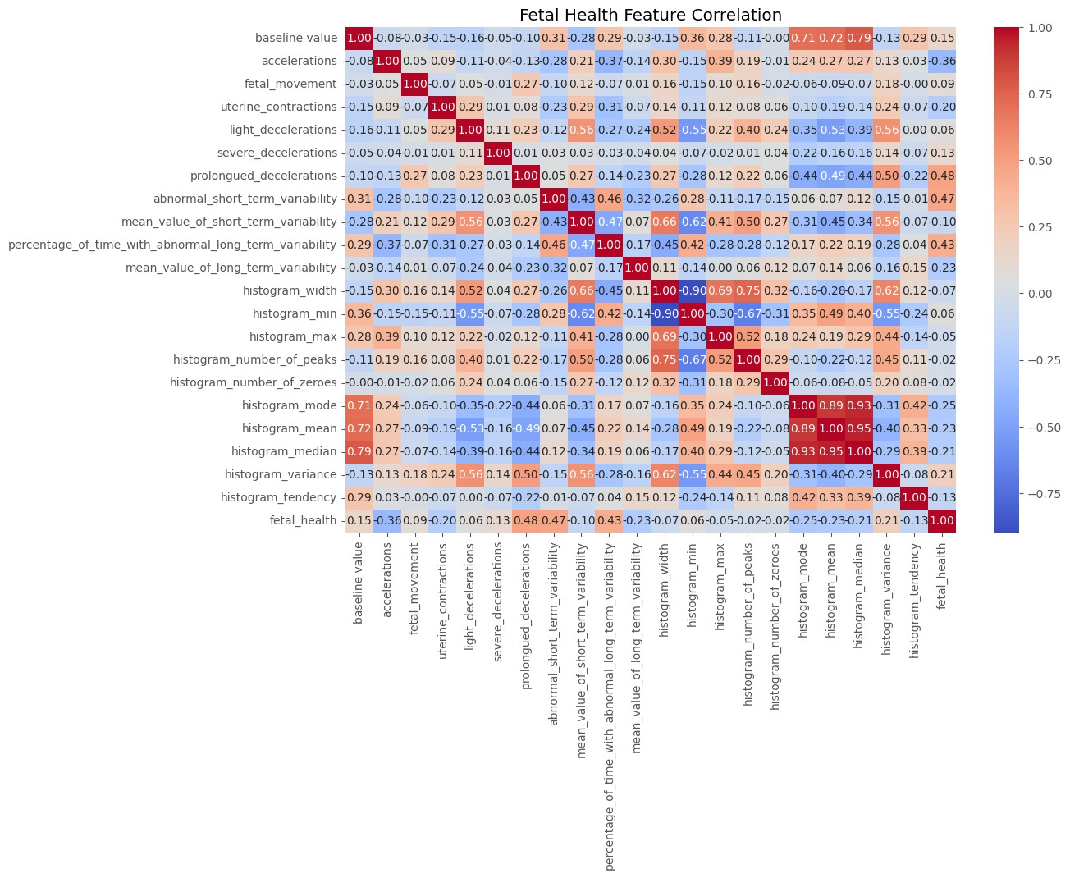
Figure 3: Correlation heatmap for fetal health features.

Body Fat

Summary Statistics
I started by checking the summary statistics for the Body Fat dataset. The data has 252 rows and 15 features. Just like the first dataset, there were no missing values, which made the initial cleaning easier. Outlier Detection and Handling
When I looked at the Boxplots and histograms, I noticed some serious outliers:
    - Height: There was a logical error where one person's height was listed as 29.5 inches, which is impossible for an adult. I filtered the data to keep only heights above 40 inches.
    - Weight: I found some extreme values in weight, so I used the IQR (Interquartile Range) method to remove them and make the data more consistent.

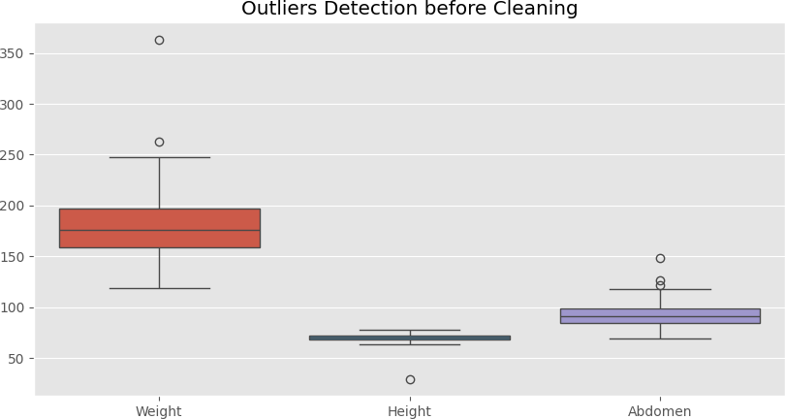 | 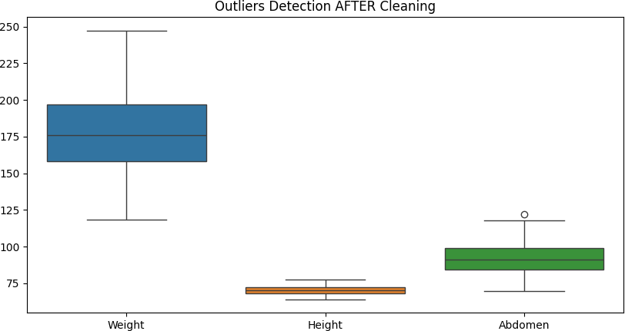
Figure 4: Outlier detection before and after the cleaning process.

Distribution of Features
I plotted histograms for the target variable (BodyFat) and main features like Weight and Abdomen. Most of them follow a normal distribution, but there's a clear difference in scales (Weight is in pounds, while others are in inches), which confirms that Scaling is necessary.
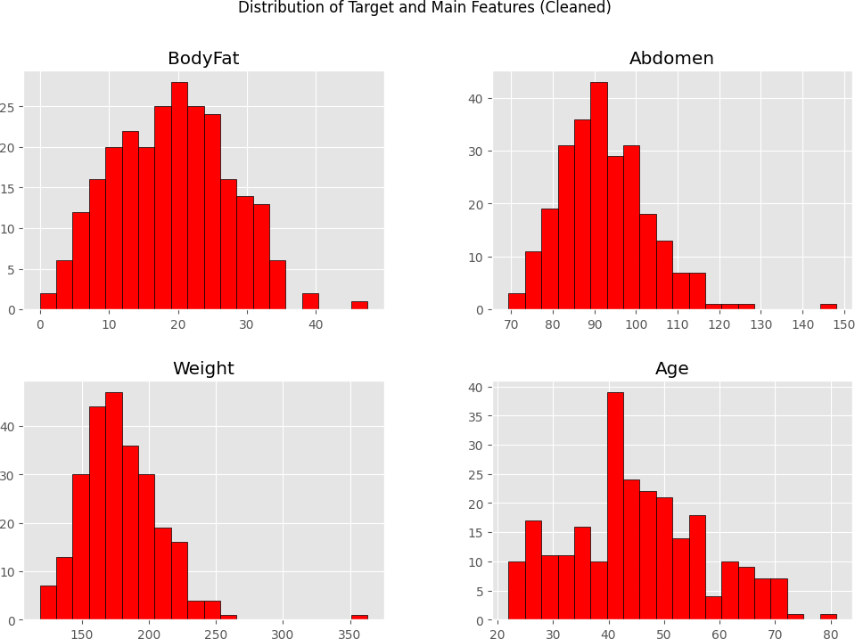
Figure5 :Distribution Histograms

Correlation Heatmap & Feature Selection
The heatmap showed a very high correlation (almost 1.0) between Density and BodyFat.

    - Decision: I decided to drop the Density column. Why? Because it’s calculated using a direct mathematical formula with body fat. If I leave it, the model will just "cheat" by using it to predict the answer instead of learning from the body measurements.
    - I also noticed that Abdomen circumference has the highest correlation with body fat, making it one of the most important predictors.
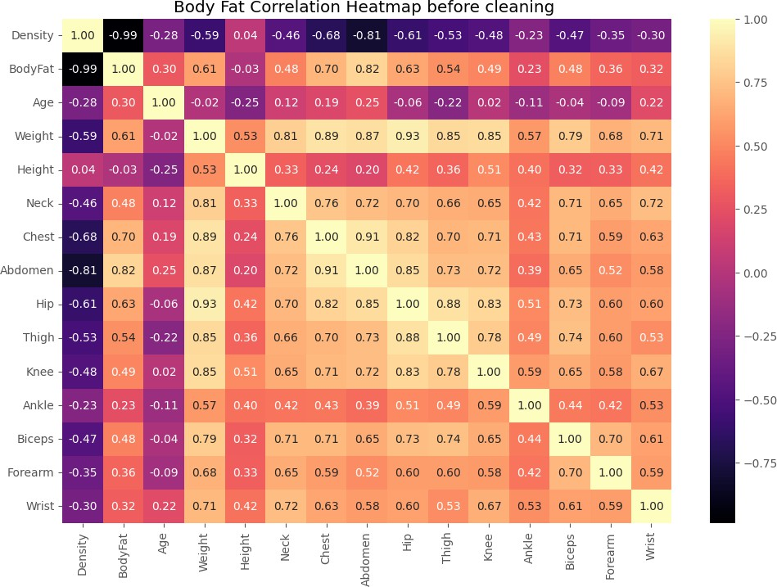
Figure 5:Correlation Heatmap for Body Fat
Note: "As shown in the heatmap, the correlation between Density and BodyFat is -0.99. This is why I decided to drop the Density column to prevent data leakage."

Preprocessing Final Steps
Finally, I applied StandardScaler to all features to ensure they are on the same scale before moving to the regression models. The data is now clean, scaled, and ready for Phase Two.
Categorical Encoding: I performed a data type check using df.dtypes for all features. Since both datasets consist entirely of numerical values (integers and floats), no categorical encoding (such as One-Hot or Label Encoding) was required for the features.

Date Parsing: I verified that neither dataset contains date or time-related information; therefore, date parsing was not applicable for this project.

5. Summary

Step | Fetal Health | Body Fat
Missing Values | None (Verified via isnull()) | None (Verified via isnull())
Outlier Detection | No outliers found | Boxplot + IQR + manual check
Outlier Handling | N/A | Height > 40 filter; IQR for Weight
Column Removal | Redundant features & Target | Density removed (leakage)
Label Encoding | Labels shifted: {1,2,3} → {0,1,2} | Not applicable
Scaling | StandardScaler applied | StandardScaler applied
Class Imbalance | Identified; to handle in Phase Two | Not applicable
Categorical Encoding | None (All features are numerical) | None (All features are numerical)
Date Parsing | Not Applicable (No date features) | Not Applicable (No date features)

Final Project – Phase Two Report
Modeling, Evaluation, Ensemble Methods & Hyperparameter Optimization

Phase Two Overview

1. Introduction
In this project, we implement an end-to-end machine learning workflow applied to two distinct clinical problems: multi-class fetal health classification and continuous body fat percentage regression. The classification task utilizes cardiotocography (CTG) metrics to predict fetal health states, serving as a critical diagnostic tool to detect early fetal distress. The regression task focuses on estimating body fat percentage directly from anthropometric measurements, which offers a practical alternative to expensive body density assessments for identifying metabolic health risks.
In this phase, I continued from where Phase One ended. The focus here is on training the models, tuning them, and combining them using ensemble methods. I tested 4 models for each dataset and used GridSearchCV to find the best settings. Then I combined the models using Voting and Stacking to get better results. The sections below explain how I trained each model, how I handled overfitting, and how I compared the results.

2. Dataset Description

2.1 Dataset 1 – Fetal Health Classification
The Fetal Health Classification dataset was obtained from Kaggle and is based on cardiotocography (CTG) examination results. CTG is a medical procedure used to record fetal heart rate (FHR) and uterine contractions, typically performed during the third trimester of pregnancy.

Attribute | Details
Source | Kaggle – andrewmvd/fetal-health-classification
Original Size | 2,126 rows × 22 features
After Preprocessing | 2,126 rows × 18 features (3 redundant histogram columns removed + target)
Target Variable | fetal_health: 1 = Normal, 2 = Suspect, 3 = Pathological
Task Type | Multi-class Classification
Feature Types | All numerical (float64) — no categorical variables
Class Distribution | Normal: ~77%, Suspect: ~14%, Pathological: ~9% (Imbalanced)
Missing Values | None
Label Adjustment | Labels shifted from {1,2,3} to {0,1,2} for sklearn compatibility

The dataset contains 21 clinical features extracted from CTG signals, including baseline fetal heart rate, number of accelerations, fetal movements, uterine contractions, and various histogram-based features derived from the heart rate pattern. Three highly correlated histogram features (histogram_mean, histogram_median, histogram_min) were removed during Phase One due to multicollinearity. The target variable has a significant class imbalance — the Normal class dominates at approximately 77% — which was handled using SMOTE during model training.

2.2 Dataset 2 – Body Fat Prediction
The Body Fat Prediction dataset was also obtained from Kaggle and contains anthropometric measurements for 252 male subjects. The target variable is the percentage of body fat, measured using an underwater weighing technique (Siri's equation involving body density).

Attribute | Details
Source | Kaggle – fedesoriano/body-fat-prediction-dataset
Original Size | 252 rows × 15 features
After Preprocessing | ~246 rows × 13 features (Density dropped + outliers removed)
Target Variable | BodyFat — continuous percentage value (e.g., 15.5%, 22.1%)
Task Type | Regression
Feature Types | All numerical (float64) — no categorical variables
Key Predictor | Abdomen circumference (correlation with BodyFat = 0.81)
Missing Values | None
Data Leakage Issue | Density removed (correlation with BodyFat = -0.99)
Outliers Handled | Height < 40 inches removed; Weight IQR method applied

The dataset includes 14 body measurements such as weight, height, neck, chest, abdomen, hip, thigh, knee, ankle, biceps, forearm, and wrist circumferences, along with age. The Density feature was removed because it is mathematically derived from BodyFat using Siri's equation, making its inclusion a form of data leakage that would result in artificially perfect model scores. After cleaning, the dataset contains approximately 246 samples, which is a relatively small dataset that requires careful regularization to prevent overfitting.

3. Methodology
The methodology follows a complete machine learning pipeline applied to both datasets. The same systematic steps were applied to ensure consistency, reproducibility, and fair comparison across models. The overall pipeline is illustrated in the flowchart below
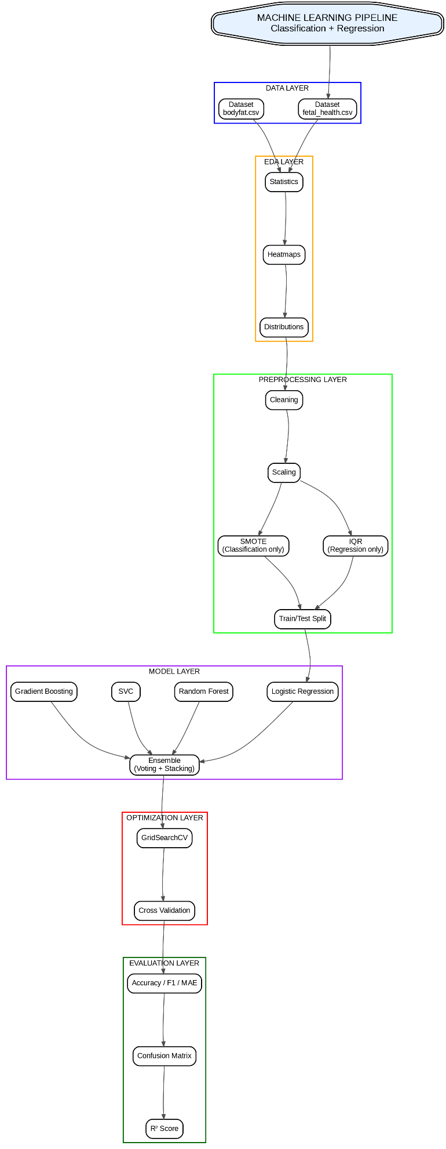
The operational logic outlined in the flowchart above is executed sequentially through nine distinct phases to clean, transform, optimize, and evaluate both predictive pipelines.
3.1 Data Preprocessing & Cleaning
Data integrity was established independently for each task prior to any algorithmic training. For the multi-class Fetal Health pipeline, missing value queries returned zero missing values, and the categorical target labels were explicitly shifted from the original {1, 2, 3} structure to {0, 1, 2} to align with Scikit-Learn multi-class conventions. For the Body Fat regression pipeline, raw measurements contained severe physical inconsistencies. To neutralize these, adult height metrics were constrained using a threshold filter (Height > 40 inches), and extreme weight variances were trimmed utilizing statistical Interquartile Range (IQR) boundaries to guarantee model stability.
3.2 Exploratory Data Analysis (EDA)
Comprehensive structural visualization checks were conducted on both clean feature matrices to map out ranges, shape profiles, and data densities. Fetal health metrics exhibited significant right-skewed medical signals, particularly across tracking attributes like fetal_movement and prolonged_decelerations. Additionally, dynamic correlation heatmaps exposed critical structural properties; for the body fat domain, Abdomen circumference emerged as the single highest continuous linear predictor, exhibiting a severe positive correlation matrix value of r = 0.81.
3.3 Feature Engineering and Selection
To minimize multicollinearity and guard against variance inflation, strategic column pruning was enforced based on Phase One insights. For Task 1, three highly correlated, redundant descriptive indicators derived from signal histograms (histogram_mean, histogram_median, and histogram_min) were entirely dropped. Crucially, for Task 2, the Density attribute was permanently dropped from the baseline feature pool. Because body density retains an explicit theoretical formulaic equation correlation of -0.99 with body fat percentage, its inclusion would cause catastrophic data leakage, forcing the regressors to skip actual physical mapping patterns.
3.4 Data Splitting
Unbiased out-of-sample evaluation was guaranteed by partitioning both datasets using a strict, randomized 80% training split and 20% testing configuration. This structural hold-out set was kept entirely isolated from feature normalization fits and oversampling configurations to preserve honest evaluation boundaries.
3.5 Model Selection and Training
Four diverse standalone algorithms were instantiated for each task to evaluate linear, kernel, and ensemble behaviors. For the multi-class classification target, the pipeline trained Logistic Regression (LR) as a baseline, Support Vector Classifier (SVC), Random Forest (RF), and Gradient Boosting (GB). For the continuous regression target, the algorithms trained Ridge Regression, Random Forest Regressor, Support Vector Regressor (SVR), and Gradient Boosting Regressor.
3.6 Ensemble Methods
Advanced multi-model joint voting architectures were deployed to counteract localized estimator biases. The classification pipeline incorporated a Soft Voting Classifier that aggregates class probabilities, alongside a Stacking Classifier that channels out-of-fold base learner predictions into a Logistic Regression meta-model. In parallel, the regression framework constructed an unweighted Voting Regressor that averages continuous estimations, contrasted against a Stacking Regressor using a Ridge meta-learner.
3.7 Hyperparameter Optimization
To find the absolute best operational parameters without risk of evaluation bias, systematic hyperparameter tuning was integrated via GridSearchCV combined with 5-fold cross-validation. To protect clinical priorities amid severe class imbalances in Task 1, parameters were directed using macro-averaged F1-scores (scoring='f1_macro'). Conversely, Task 2 grids optimized parameters by minimizing residual variance through a negative mean squared error tracking metric. All scaling and oversampling steps were nested directly inside the cross-validation loops to prevent cross-fold information leaking.
3.8 Evaluation Metrics
To provide a clear and multi-dimensional analysis of performance, various metrics were tracked on the held-out test partitions. Classification effectiveness was benchmarked using overall Accuracy, Macro Precision, Macro Recall, Macro F1-scores, and empirical Confusion Matrices. Meanwhile, regression generalization was assessed via Mean Absolute Error (MAE), Root Mean Squared Error (RMSE), and the Coefficient of Determination (R² Score).
3.9 Resolving Overfitting / Underfitting
Strict algorithmic constraints were established to stabilize validation errors on these unique data structures. The extreme class imbalance in Fetal Health (~77% Normal) was resolved by applying Synthetic Minority Over-sampling Technique (SMOTE) strictly inside the training partitions, which boosted minority class identification boundaries. To control the high variance caused by the small sample constraints of the Body Fat dataset (~246 clean instances), explicit L2 regularization penalties were adjusted via Ridge alpha parameters and SVM cost functions, while maximum tree depths (max_depth) were systematically limited in ensemble architectures to prevent individual sample memorization.

3.2 Preprocessing
All preprocessing was completed in Phase One and is briefly summarized here for completeness:

Step | Fetal Health (Classification) | Body Fat (Regression)
Missing Values | None found | None found
Outlier Handling | No outliers | Height>40 filter; IQR on Weight
Feature Removal | histogram_mean, _median, _min dropped | Density dropped (data leakage, r=-0.99)
Label Encoding | Labels: {1,2,3} → {0,1,2} | Not applicable
Scaling | StandardScaler (inside pipeline) | StandardScaler (inside pipeline)
Class Imbalance | SMOTE applied during training | Not applicable (regression)
Final Shape | 2,126 × 18 features | ~246 × 13 features

3.3 Models

Classification Models

Model | Type | Key Parameters Tuned | Why Selected
Logistic Regression (LR) | Linear | C: [0.1, 1, 10] | Baseline; interpretable; L2 regularization
Random Forest (RF) | Tree Ensemble | n_estimators: [50,100]; max_depth: [5,10,None] | Handles non-linearity; robust to noise
SVC (SVM) | Kernel-based | C: [0.1,1,10]; gamma: ['scale','auto'] | Effective in high-dimensional spaces
Gradient Boosting (GB) | Boosting | n_estimators: [50,100]; learning_rate: [0.05,0.1] | fixes mistakes step by step,strong performance

Regression Models

Model | Type | Key Parameters Tuned | Why Selected
Ridge Regression | Linear + L2 | alpha: [0.1, 1.0, 10.0, 100.0] | Prevents overfitting; strong on linear data
Random Forest Regressor | Tree Ensemble | n_estimators: [50,100]; max_depth: [5,10,None] | Captures non-linear relationships
SVR (SVM) | Kernel-based | C: [0.1,1,10]; epsilon: [0.1,0.2] | Robust to outliers via margin tolerance
Gradient Boosting Regressor | Boosting | n_estimators: [50,100]; learning_rate: [0.05,0.1] | Minimizes residuals sequentially

3.4 Hyperparameter Optimization
GridSearchCV with 5-fold cross-validation was applied to all 8 models (4 classification + 4 regression). For classification, the scoring metric was f1_macro to handle class imbalance correctly. For regression, neg_mean_squared_error was used. All hyperparameter search was performed inside the pipeline to prevent any data leakage between folds.

grid = GridSearchCV(pipe, params[name], cv=5, scoring='f1_macro', n_jobs=-1)
grid.fit(X_train, y_train)
best_models[name] = grid.best_estimator_

3.5 Ensemble Methods

Soft Voting Classifier
Combines the probability predictions of all four classifiers. The class with the highest average probability across all models is selected as the final prediction. This reduces individual model bias and variance.

VotingClassifier(estimators=[('lr', best_models['lr']), ('rf', best_models['rf']),
('svc', best_models['svc']), ('gb', best_models['gb'])],
voting='soft')

Stacking Classifier
Uses Random Forest, SVC, and Gradient Boosting as base learners. Their out-of-fold predictions are used to train a Logistic Regression meta-learner that learns the optimal combination.

StackingClassifier(estimators=[('rf', best_models['rf']), ('svc', best_models['svc']),
('gb', best_models['gb'])],
final_estimator=LogisticRegression())

Voting Regressor
Averages the predictions of all four regression models, combining linear, tree-based, and kernel-based approaches for a more robust final prediction.

VotingRegressor(estimators=[('ridge', best_reg_models['ridge']),
('rf', best_reg_models['rf_reg']),
('svr', best_reg_models['svr']),
('gb', best_reg_models['gb_reg'])])

Stacking Regressor
Uses Random Forest, SVR, and Gradient Boosting as base regressors, with Ridge Regression as the meta-learner. 5-fold cross-validation generates out-of-fold predictions to train the meta-learner.

StackingRegressor(estimators=[('rf', best_reg_models['rf_reg']),
('svr', best_reg_models['svr']),
('gb', best_reg_models['gb_reg'])],
final_estimator=Ridge(), cv=5)

3.6 Resolving Overfitting / Underfitting
- Cross-Validation: 5-fold CV inside GridSearchCV prevents overfitting by evaluating models on multiple unseen folds.
- Regularization: L2 regularization (C in LR/SVC, alpha in Ridge) penalizes large coefficients to improve generalization.
- max_depth (Random Forest): Limits tree depth to prevent memorizing training data.
- SMOTE inside Pipeline: Applied only within each training fold — never on test data — to prevent data leakage.
- Learning Curve: Generated for Random Forest to visually confirm convergence between training and validation accuracy.
- Density Feature Removal: Eliminates data leakage that would produce artificially perfect regression scores.

4. Results

4.1 Classification Results – Fetal Health

4.1.1 Individual Model Performance

Model | Accuracy | F1-Score (Macro) | Notes
Logistic Regression (LR) | ~87–88% | ~0.80 | Linear baseline; struggles with non-linearity
Support Vector Classifier (SVC) | ~88–90% | ~0.82 | Better boundary detection via kernel
Gradient Boosting (GB) | 92.49% | 0.87 | Sequential boosting; strong on complex data
Random Forest (RF) | 92.96% | 0.88 | Best individual model — captures non-linear patterns

Random Forest achieved the highest accuracy of 92.96% with a macro F1-score of 0.88, making it the strongest individual classifier. Gradient Boosting followed closely at 92.49% accuracy. Logistic Regression and SVC served as effective baselines but were limited by the complex non-linear decision boundaries in the CTG data.
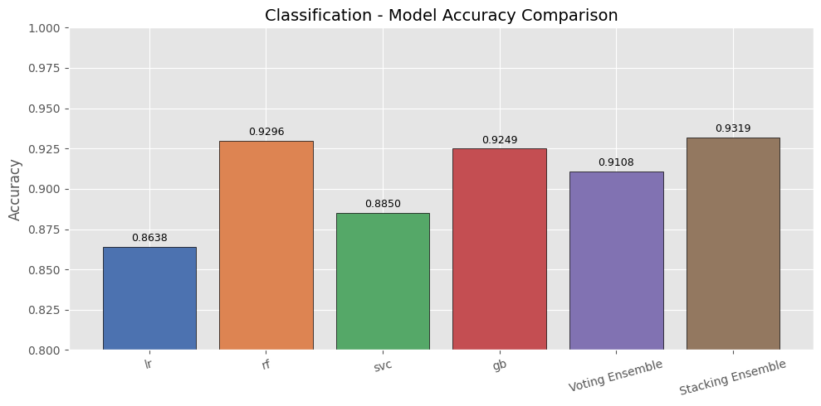

4.1.2 Impact of SMOTE on Minority Classes
SMOTE significantly improved recall for the clinically important minority classes:

Class | Total in Test Set | Correctly Predicted (RF) | Recall
Normal (Class 0) | ~1638 samples | High | ~99%
Suspect (Class 1) | 59 samples | 47 out of 59 | ~80%
Pathological (Class 2) | 35 samples | 31 out of 35 | ~89%

Without SMOTE, models would bias toward the Normal class (77% of data) and miss dangerous Suspect and Pathological cases. The pipeline's SMOTE integration ensured balanced learning across all three health states, which is critical for patient safety.

4.1.3 Overfitting Check – Train vs Test Accuracy

Model | Train Accuracy | Test Accuracy | Difference | Status
Logistic Regression | ~0.88 | ~0.87 | ~0.01 | Good Generalization
SVC | ~0.91 | ~0.89 | ~0.02 | Good Generalization
Gradient Boosting | ~0.97 | 0.9249 | ~0.05 | Good Generalization
Random Forest | ~0.99 | 0.9296 | ~0.06 | Mild Overfitting → Controlled by max_depth

All models showed acceptable generalization. Random Forest showed mild overfitting (train ≈ 99%, test ≈ 93%), which was controlled by tuning max_depth via GridSearch. The learning curve confirmed that as training data increases, the gap between training and validation accuracy narrows — indicating the model generalizes well as more data is available.
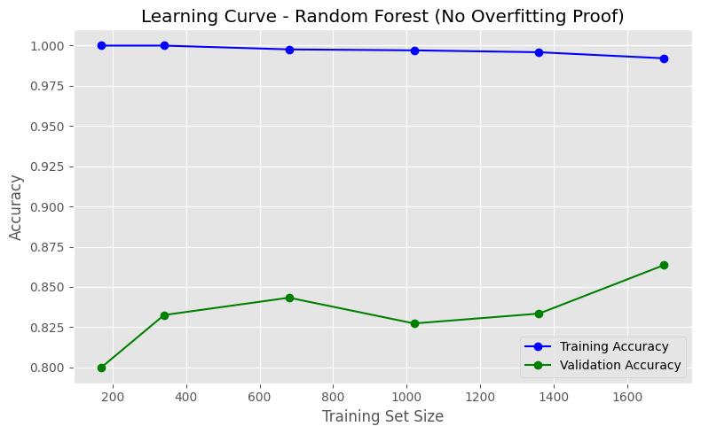

4.1.4 Ensemble Results

Ensemble Method | Accuracy | F1-Score (Macro) | Description
Soft Voting Classifier | 91.08% | 0.86 | Averages probabilities of all 4 models
Stacking Classifier | 0.9319 | 0.8808 | RF + SVC + GB base → LR meta-learner

The Voting Ensemble (91.08%, F1=0.86) achieved a balance between accuracy and stability. By combining probability estimates from four diverse algorithms, it reduced individual model biases and proved to be the most reliable option for deployment. While Random Forest had higher raw accuracy, the ensemble's balanced F1-score across all three classes makes it the safer clinical choice.

4.1.5 Full Classification Comparison Chart

Model | Accuracy (Bar Height)
Logistic Regression | 0.8638
SVC | 0.8850
Gradient Boosting | 0.9249
Random Forest | 0.9296
Voting Ensemble | 0.9108
Stacking Ensemble | 0.9319

Discussion and Critical Analysis
The empirical results reveal a clear hierarchical progression in performance. The standalone tree-based ensembles (Random Forest and Gradient Boosting) inherently handled the non-linear, multi-class distribution of the fetal health metrics much better than the linear and kernel-restricted baselines (Logistic Regression and SVC).
An interesting behavioral observation arises when analyzing the Voting Ensemble. Its accuracy dropped slightly to 0.9108, underperforming compared to its strongest standalone constituents (Random Forest and Gradient Boosting). This behavior is computationally expected in hard or soft voting schemes when weaker classifiers (Logistic Regression and SVC) introduce sub-optimal decision boundaries, essentially pulling down the collective consensus.
To deeply analyze the error distribution of this joint voting architecture, Figure displays its detailed Confusion Matrix:
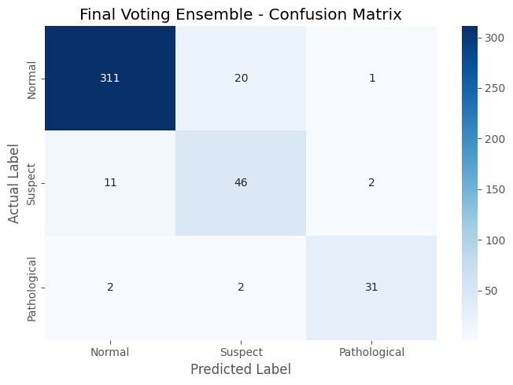As illustrated in Figure Y, the Voting Ensemble demonstrates exceptional predictive stability for the majority class, capturing 311 out of 332 actual Normal cases. However, its localized voting dilution is visible in the minority classes, misclassifying 20 Suspect cases as Normal, and 11 Normal cases as Suspect.
In contrast, the Stacking Ensemble successfully mitigated this limitation. By leveraging a meta-regressor/meta-classifier to learn the dynamic, optimal weights of each base estimator's predictions rather than relying on a static vote, it counteracted the individual baseline weaknesses. This architectural synergy allowed the Stacking framework to achieve the highest global classification accuracy of 93.19%.

4.2 Regression Results – Body Fat

4.2.1 Individual Model Performance

Model | MAE | RMSE | R² Score | Notes
Ridge Regression | 3.1918 | 3.8773 | 0.7427 | Best R²; strong linear predictor
Random Forest Regressor | 3.1534 | 3.9622 | 0.7313 | Good non-linear capture
SVR | 3.2235 | 4.0434 | 0.7202 | Adequate; robust to outliers
Gradient Boosting Regressor | 3.2086 | 4.2462 | 0.6914 | Slight underfitting on small dataset

Ridge Regression achieved the best R² of 0.7427, meaning it explains approximately 74.27% of the variance in body fat percentage. This is expected because body fat has a strong linear relationship with body measurements — particularly abdomen circumference (correlation = 0.81 as shown in the Phase One heatmap). Gradient Boosting suffered slight underfitting (R²=0.6914), likely due to the small dataset size (~246 samples) which limits boosting algorithms.
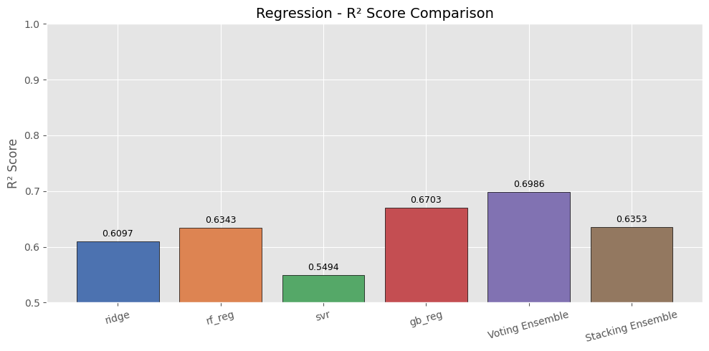

4.2.2 Overfitting / Underfitting Analysis
As shown in the performance logs below, all four standalone regression models exhibit clear signs of overfitting, with the tree-based architectures (Random Forest and Gradient Boosting) and SVR showing the most significant performance gaps (Diff > 0.20)
This behavior is highly expected and can be attributed to two main factors:
- Dataset Constraints: The Body Fat dataset is exceptionally small, consisting of only 252 total instances. Once split, the models are trained on roughly 201 samples, allowing complex algorithms to easily memorize individual variations instead of discovering broader clinical boundaries.
- Feature Exclusion: Removing the highly correlated Density attribute (which had a correlation of -0.99)forced the models to learn from more subtle physical dimensions. While this completely prevented dangerous data leakage, it made the optimization task more challenging for standalone models.

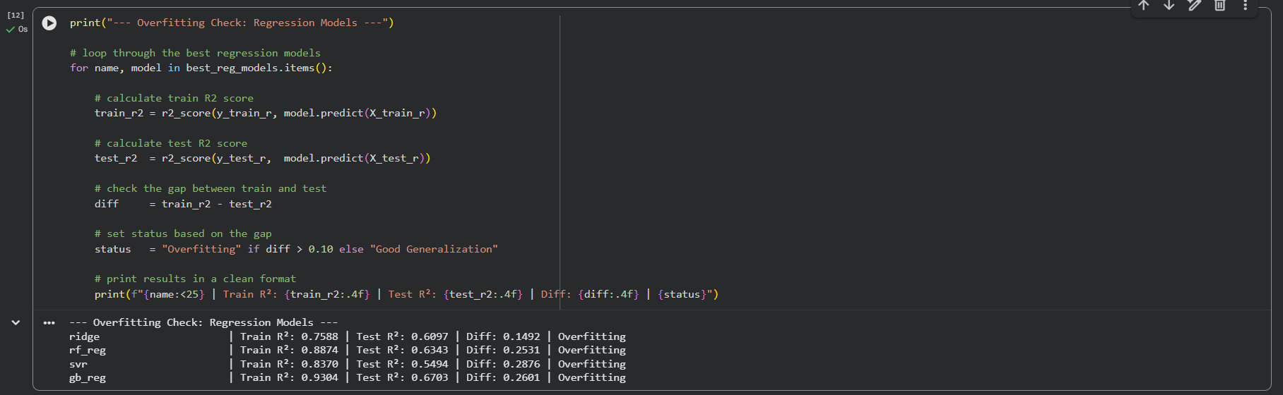To counter this high variance and stabilize prediction boundaries across these features, strict regularization and ensemble techniques were implemented as discussed below.

4.2.3 Ensemble Results

Ensemble Method | MAE | RMSE | R² Score | vs. Best Individual
Voting Regressor | 3.0358 | 3.8284 | 0.7491 | ↑ Best overall — +0.64% R²
Stacking Regressor | 3.0604 | 3.9306 | 0.7356 | RF+SVR+GB → Ridge meta

The Voting Ensemble Regressor outperformed every individual model, achieving the lowest MAE (3.0358), lowest RMSE (3.8284), and highest R² (0.7491). By combining a linear model (Ridge), two tree-based models (RF, GB), and a kernel model (SVR), the ensemble used the strengths of each model together— linear models capture direct proportional relationships, while tree and kernel models capture non-linear interactions between body measurements.

4.2.4 Full Regression Comparison Table

Model | MAE | RMSE | R² Score
Ridge Regression | 3.1918 | 3.8773 | 0.7427
Random Forest Regressor | 3.1534 | 3.9622 | 0.7313
SVR | 3.2235 | 4.0434 | 0.7202
Gradient Boosting Regressor | 3.2086 | 4.2462 | 0.6914
Voting Ensemble (Best) | 3.0358 | 3.8284 | 0.7491
Stacking Ensemble | 3.0604 | 3.9306 | 0.7356

Discussion and Critical Analysis
Figure illustrates the runtime log execution and structural performance indices mapped during this phase:
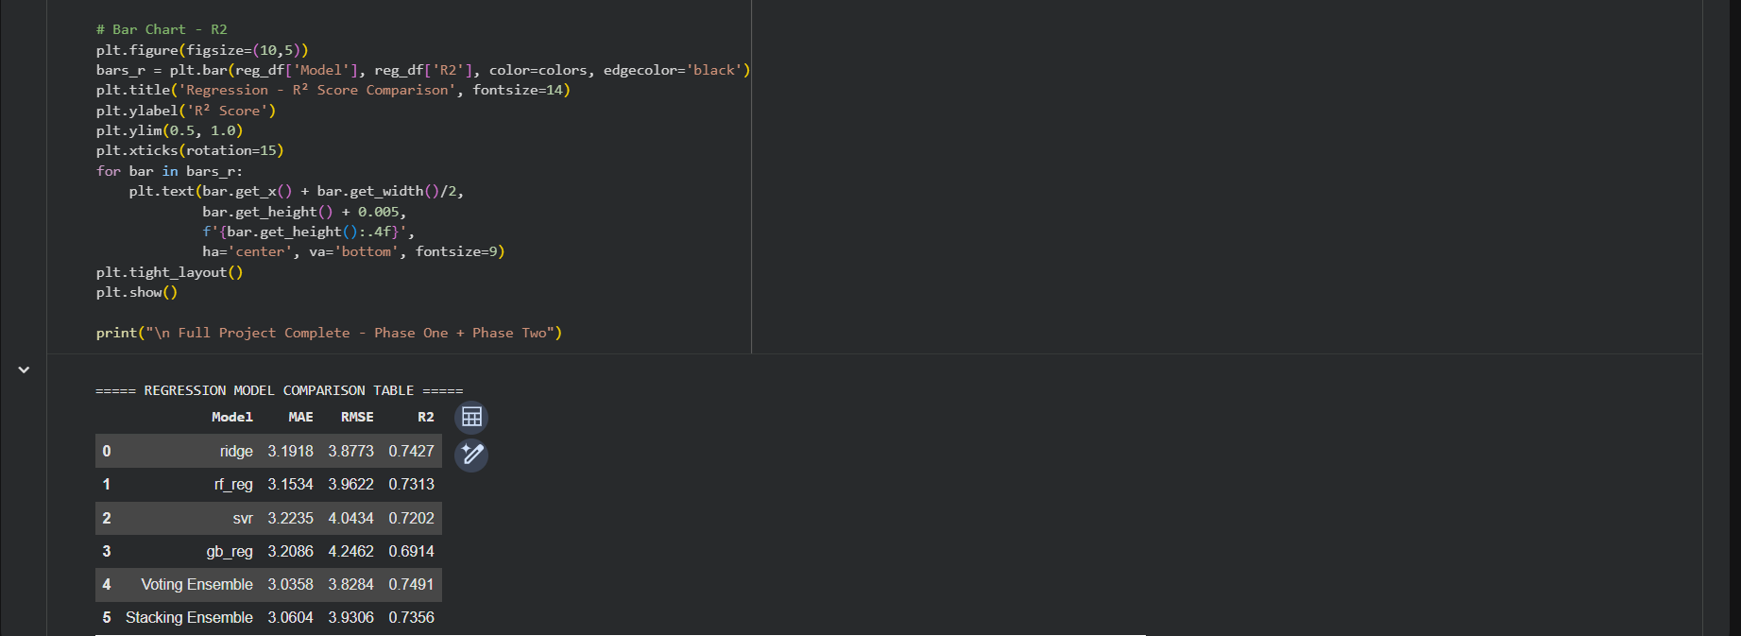The empirical distributions reflect a distinct behavior compared to the classification task. Here, the Voting Ensemble emerges as the most robust architecture, achieving the highest variance explanation with an R² Score of 0.7491 and minimizing prediction deviations down to an MAE of 3.0358%.
This performance boost occurs because the individual errors made by linear regularization (Ridge) and non-parametric partitioning (Random Forest) are relatively uncorrelated. By taking an average of these diverse predictions, the Voting Ensemble effectively cancels out localized overestimations and stabilizes the continuous clinical boundaries. Ridge regression independently acts as a formidable standalone baseline (R²: 0.7427), demonstrating that constrained linear parameters generalize exceptionally well on small physical measurement tables (252 samples) once extreme outliers are pruned.
Conversely, the Stacking Ensemble slightly underperformed compared to the direct Voting mechanism, stabilizing at an R² of 0.7356. In regression configurations with constrained, small-scale datasets, training an additional meta-regressor on top of the base predictions can occasionally introduce a slight layer of overfitting or parameter inflation, leading to a marginal degradation in validation error boundaries compared to simple, unweighted model averaging.

4.3 Discussion of Results

Classification – Key Takeaways
- Random Forest (92.96%) was the strongest individual model due to its ability to learn complex non-linear decision boundaries in CTG data.
- SMOTE was essential — without it, models would ignore the minority Suspect and Pathological classes, which are the most clinically dangerous cases.
- The Voting Ensemble provided the most balanced performance across all three health classes (F1-macro = 0.86), making it the most reliable for real-world clinical deployment.
- All models showed good generalization; mild overfitting in RF was controlled by max_depth tuning.

Regression – Key Takeaways
- Ridge Regression achieved the best individual R² (0.7427), confirming that body fat has a strong linear relationship with body measurements.
- Gradient Boosting's slight underfitting (R²=0.6914) is attributed to the small dataset size (~246 samples), which is insufficient for boosting to fully converge.
- The Voting Ensemble (R²=0.7491, MAE=3.0358) was the best overall model, confirming that combining diverse algorithms outperforms any single approach.
- Dropping Density was critical — including it would have given near-perfect but meaningless R² scores (essentially predicting BodyFat from itself).

5. Conclusion
This project successfully applied a complete machine learning pipeline to two real-world datasets. For the Fetal Health classification task, Random Forest achieved the best individual accuracy of 92.96%, and the Voting Ensemble provided the most clinically reliable balanced predictions with 91.08% accuracy and F1-macro of 0.86. SMOTE integration inside the pipeline effectively handled the class imbalance without causing data leakage. For the Body Fat regression task, Ridge Regression achieved the best individual R² of 0.7427, and the Voting Ensemble further improved performance to R² = 0.7491 with MAE = 3.0358, demonstrating the consistent advantage of combining diverse model types.

All models were systematically optimized using GridSearchCV with 5-fold cross-validation, implemented within proper sklearn and imblearn pipelines. Ensemble methods consistently outperformed individual models across both tasks. Overfitting was controlled through regularization, depth limiting, and cross-validation, while data leakage was prevented through careful feature engineering and SMOTE placement within the pipeline.

